**MODULE – 3(Core PHP)**

1. Write a PHP program to enter marks of five subjects Physics, Chemistry, Biology, Mathematics and Computer, calculate percentage and grade by if else

<?php

$physics = 90;

$chemistry = 80;

$biology = 70;

$mathematics = 60;

$computer = 50;

$total = NULL;

$percentage = NULL;

$grade = NULL;

$total = $physics + $chemistry + $biology + $mathematics + $computer;

$percentage = ($total / 500.0) * 100;

if ($percentage >= 90)

$grade = "A";

else if ($percentage >= 80 && $percentage < 90)

$grade = "B";

else if ($percentage >= 70 && $percentage < 80)

$grade = "C";

else if ($percentage >= 60 && $percentage < 70)

$grade = "D";

else

$grade = "E";

echo "The Percentage : " . $percentage . "<br>";

echo "The Grade : " . $grade;

?>

Output:



1. Write a PHP program for find „Thursday‟ in week using switch Function.

<?php

$day = "4";

switch ($day)

{

case "1":

echo "It is Monday";

break;

case "2":

echo "It is Tuesday";

break;

case "3":

echo "It is Wednesday";

break;

case "4":

echo "It is Thursday";

break;

case "5":

echo "It is Friday";

break;

case "6":

echo "It is Saturday";

break;

case "7":

echo "It is Sunday";

break;

default:

echo "Invalid number";

}

?>

Output:



1. Write a PHP program to check Leap years between 1901 to 2016 Using nested if.

<?php

for($year=1901; $year<=2016; $year++)

{

if ($year % 4 == 0)

echo $year." : is a leap year<br>" ;

else

echo $year." : is not a leap year<br>";

}

?>

Output: 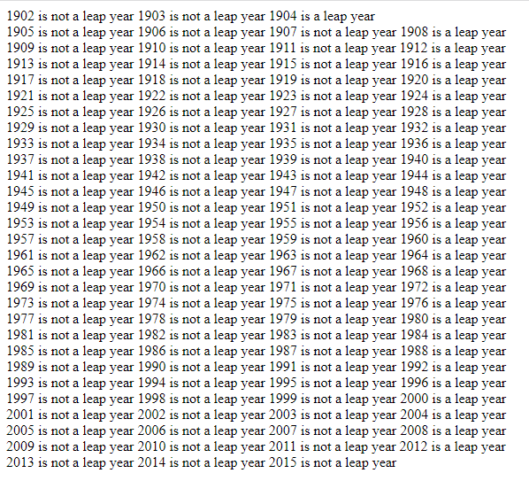

1. Write a PHP program to find the largest of three numbers using ternary Operator.

<?php

$x=10;

$y=20;

$z=15;

$max = ($x > $y)? (($x > $z)? $x : $z) : (($y > $z)? $y : $z);

echo "Largest number among $x, $y and $z is: $max\n";

?>

Output:



1. Write a program in PHP to print Fibonacci series. 0, 1, 1, 2, 3, 5, 8, 13, 21, 34

<?php

$num = 0;

$n1 = 0;

$n2 = 1;

echo $n1.' '.$n2.' ';

while ($num < 8 )

{

$n3 = $n2 + $n1;

echo $n3.' ';

$n1 = $n2;

$n2 = $n3;

$num = $num + 1;

}

?>

Output:



1. Write a program to print the below format :

159

2610

4812

<?php

for($i = 1; $i <= 4; $i++)

{

$print = $i;

for($j = 0; $j <= 2; $j++)

{

echo $print. "&nbsp";

$print = $print + 4;

}

echo "<br>";

}

?>

Output:



1. Write a program for this Pattern:

*****

*

*

*

*****

<?php

for ($i=0; $i<=4; $i++)

{

for ($j=0; $j<=5; $j++)

{

if ($j == 1 or ($i == 0 and $j > 1 and $j < 6) or ($i == 4 and $j > 1 and $j < 6 ))

echo "* ";

}

echo "<br>";

}

?>

Output:

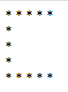

1. What will be the values of $a and $b after the code below is executed? Explain your answer.

$a = '1';

$b = &$a;

$b = "2$b";

$a = '1'; // $a is a variable type of string with the value '1';

$b = &$a; // $b is the reference of the $a variable.

$b = "2$b"; // $b & $a have for value the string '2' concatenate with the value of the variable $a (string '1')

So the output of value a & b is 21.

1. How can you tell if a number is even or odd without using any Condition or loop?

<?php

$arr=array("0"=>"Even","1"=>"Odd");

$check=10;

echo "Your number is: ".$arr[$check%2];

?>

Output :



• Write program to remove duplicate values from array

-> array_unique function. This function will remove the duplicate values from the array.

Syntax:

array array_unique($array, $sort_flags)

<?php

$a = array("red", "green", "pink", "blue","green");

print_r(array_unique($a));

?>

• Get random values from array

-> There are two functions to get random value out of an array in PHP. The shuffle() and array_rand() function is used to get random value out of an array.

Php array_rand: The array_rand() function is an inbuilt function in PHP which is used to fetch a random number of elements from an array. The element is a key and can return one or more than one key.

Syntax: array_rand( $array, $num )

This function accepts two parameters $array and $num. The $array variable store the array elements and $num parameter holds the number of elements need to fetch. By default value of this parameter is 1.

<?php

$arr = array( "a"=>"21", "b"=>"31", "c"=>"7", "d"=>"20" );

$key = array_rand($arr);

echo $arr[$key];

?>

• Write a PHP script which decodes the following JSON string

-> The json_decode() function is used to decode or convert a JSON object to a PHP object.

Syntax:

json_decode(string, assoc, depth, options)

<?php

$jsonobj = '{"Peter":35,"Ben":37,"Joe":43}';

var_dump(json_decode($jsonobj, true));

?>

Use a for loop to total the contents of an integer array called numbers which has five elements. Store the result in an integer called total.

<?php

$arr =array(12, 3, 4, 15, 10);

$n = sizeof($arr);

$sum=0;

for ($i = 0; $i < $n; $i++)

{

$sum = $sum + $arr[$i];

}

echo "Sum of given array is " . $sum;

?>

Declare a Multi Dimensioned array of floats called balances having Three rows and five columns.

<?php

$float = array (

array(1.1,22.5,18,15.5,16.5),

array(1.5,15,13,12.12,10),

array(1.7,5,2,10.10,5.5)

);

for ($row = 0; $row < 3; $row++) {

echo "<p><b>Row number $row</b></p>";

for ($col = 0; $col < 5; $col++) {

echo "<li>".$float[$row][$col]."</li>";

}

}

?>